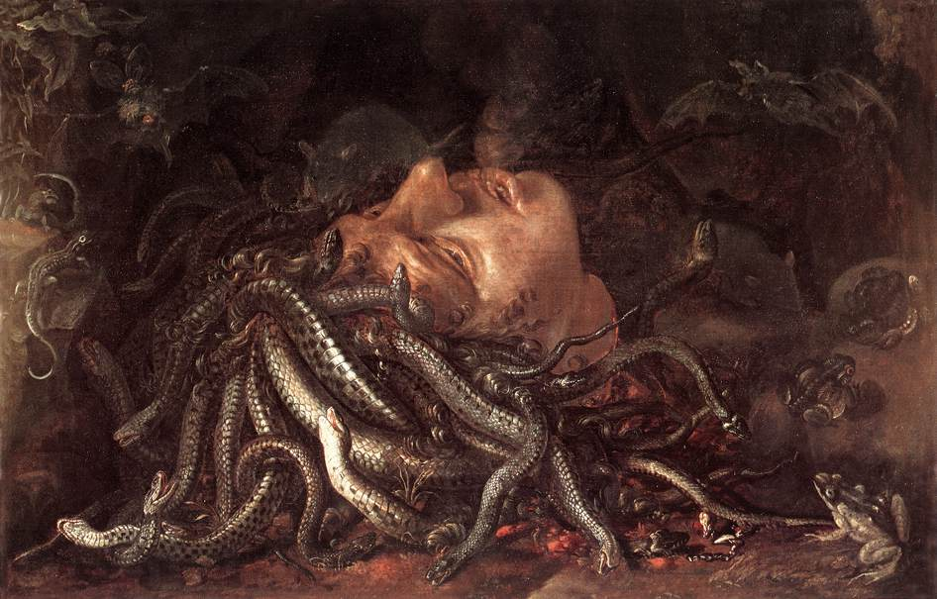

The Head of Medusa

[Percy Bysshe Shelley: “On the Medusa of Leonardo Da Vinci in the Florentine Gallery,” as read by an unknown male speaker](https://youtu.be/fcOdzJmqatQ)

# On the Medusa of Leonardo Da Vinci in the Florentine Gallery

By Percy Bysshe Shelley - 1792-1822

It lieth, gazing on the midnight sky,

Upon the cloudy mountain peak supine;

Below, far lands are seen tremblingly;

Its horror and its beauty are divine.

Upon its lips and eyelids seems to lie

Loveliness like a shadow, from which shrine,

Fiery and lurid, struggling underneath,

The agonies of anguish and of death.

Yet it is less the horror than the grace

Which turns the gazer's spirit into stone;

Whereon the lineaments of that dead face

Are graven, till the characters be grown

Into itself, and thought no more can trace;

'Tis the melodious hue of beauty thrown

Athwart the darkness and the glare of pain,

Which humanize and harmonize the strain.

And from its head as from one body grow,

As [ ] grass out of a watery rock,

Hairs which are vipers, and they curl and flow

And their long tangles in each other lock,

And with unending involutions shew

Their mailed radiance, as it were to mock

The torture and the death within, and saw

The solid air with many a ragged jaw.

And from a stone beside, a poisonous eft

Peeps idly into those Gorgonian eyes;

Whilst in the air a ghastly bat, bereft

Of sense, has flitted with a mad surprise

Out of the cave this hideous light had cleft,

And he comes hastening like a moth that hies

After a taper; and the midnight sky

Flares, a light more dread than obscurity.

'Tis the tempestuous loveliness of terror;

For from the serpents gleams a brazen glare

Kindled by that inextricable error,

Which makes a thrilling vapour of the air

Become a [ ] and ever-shifting mirror

Of all the beauty and the terror there—

A woman's countenance, with serpent locks,

Gazing in death on heaven from those wet rocks.

# Further Information about the Artwork:

**Title:** Head of Medusa

**Artist:** Flemish School, (16th century) / Flemish

**Current Location:** Galleria degli Uffizi, Florence, Tuscany, Italy

**Medium:** oil on panel

**Dimensions:** 49x74 cms

According to Romantic Circles, “The "Head of the Medusa" that inspired Shelley is now attributed to the Flemish School, circa 1620-30. The painting is owned by the Uffizi Gallery in Florence, inventory number P1472.”

Creative Commons License

This work is licensed under a [Creative Commons Attribution 4.0 International License](http://creativecommons.org/licenses/by/4.0/).